Novara Fashion Store
E-commerce Sales Analysis and Business insights 2022
Total Sales | Total Order | Average Sales Record
21176377 | 31047 | 682.07

Executive Summary
Across 31,047 orders in 2022, Novara Fashion recorded total sales amount of 21,76,377. Women account for 64.0% of sales, Amazon is the largest sales channel at 35.5%, and the Set and kurta categories together represent 73.6% of order records. Monthly sales peak in Match and reach Their lowest point in November, indicating a need to investigate seasonality and late-year demand.
Sales Performance over time
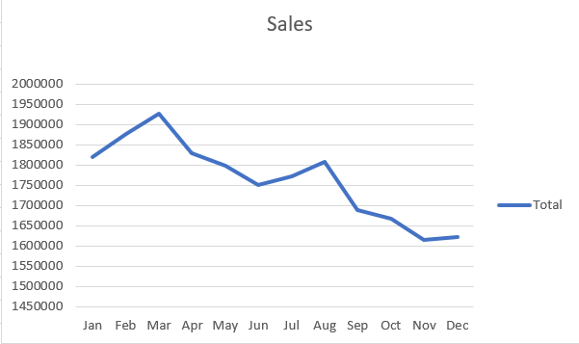
Finding 1 – Match is the strongest month. sales reached 1,928,066 highest totals about 9.1% of annual sales. November was the lowest month at 1,615,356 about 7.63% of annual sales.
Finding 2 – The second half trends softer. From the March peak monthly sales generally ease through the later month with slight rebound in August followed by a lower September-November period. December improves slightly over November.

Business Suggestions / Recommendations
1. Optimize inventory for peak demand
Increase stock availability before March by analysing top-selling products and historical demand. This can help the business avoid stockouts and maximize revenue during the strongest sales period.
2. Introduce targeted promotions during low-sales months
Launch discount campaigns, festive offers, bundle deals, and loyalty rewards during September to November to stimulate customer demand and improve monthly sales performance.
3. Investigate the July–August sales recovery
Analyse product categories, marketing campaigns, and customer purchasing behaviour during July and August to identify factors that may have contributed to the improvement. Replicate successful strategies in weaker months where appropriate.
4. Strengthen year-end marketing strategies
Capitalize on the slight December recovery by implementing year-end promotions, seasonal campaigns, and personalized recommendations to encourage additional purchases.
5. Conduct product-level sales analysis
Identify high-performing and low-performing clothing categories, sizes, and products. Allocate inventory and marketing budgets toward products with strong demand and profitability.

